
RAMAIAH
Institute of Technology
USN | 1 | M | S

(Autonomous Institute, Affiliated to VTU)
(Approved by AICTE, New Delhi & Govt. of Karnataka) Accredited by NBA & NAAC with ‘A’ Grade

SEMESTER END EXAMINATIONS JANUARY – FEBRUARY 2021
Program | : | B.E. : Computer Science and Engineering | Semester | : | V
Course Name | : | Computer Networks | Max. Marks | : | 100
Course Code | : | CS53 | Duration | : | 3 Hrs

Instructions to the Candidates:
- Answer one full question from each unit.
- Write figures wherever necessary.

 |  | UNIT- I
1. | a) | Explain HTTP request message format with an example. | CO1 | (06)
 | b) | Differentiate between persistent and non persistent TCP connections of HTTP with an example. | CO1 | (06)
 | c) | - Describe how Web caching can reduce the delay in receiving a requested object. Will Web caching reduce the delay for all objects requested by a user or for only some of the objects? Why?  - From a user’s perspective, what is the difference between the download-and-delete mode and the download-and-keep mode in POP3? | CO1 | (08)
2. | a) | Explain the services provided by DNS server in a network. | CO1 | (06)
 | b) | Describe DHT and circular DHT with example. | CO1 | (06)
 | c) | - Suppose Alice, with a Web-based e-mail account (such as Hotmail or gmail), sends a message to Bob, who accesses his mail from his mail server using POP3. Discuss how the message gets from Alice’s host to Bob’s host. Be sure to list the series of application-layer protocols that are used to move the message between the two hosts.  - Is it possible for an organization’s Web server and mail server to have exactly the same alias for a hostname (for example, foo.com)? What would be the type for the RR that contains the hostname of the mail server? | CO1 | (08)
 |  | UNIT – II
3. | a) | Explain connection oriented multiplexing and demultiplexing with an example. | CO2 | (06)
 | b) | Describe the steps involved in estimation of round trip time. | CO2 | (06)
 | c) | With neat diagram explain the TCP states visited by client and server. | CO2 | (08)
4. | a) | Explain TCP frame format with neat figure. | CO2 | (08)
 | b) | Define the variables of TCP flow control and explain how flow control service eliminates the overflowing of receiver buffer. | CO2 | (06)
 | c) | Illustrate the TCP Tahoe and TCP Reno congestion window mechanism with an example. | CO2 | (06)
 |  | UNIT – III
5. | a) | Explain Dijkstra’s algorithm for shortest path calculation of routes in a network. | CO3 | (06)
 | b) | Differentiate between IPv4 and IPv6. Consider sending a 3000 bytes datagram into a link that has an MTU of 500 bytes. Suppose the original datagram is stamped with identification number 422. How many fragments are generated? What are their characteristics? | CO3 | (08)
 | c) | An organization is granted a block of addresses with the beginning address 195.1.2.0/24. The organization needs to have 3 subblocks of addresses to use in its three subnets: one subblock of 10 addresses, one subblock of 60 addresses, and one subblock of 120 addresses. Design the subblocks. | CO3 | (06)
6. | a) | Consider the network shown below.  - Find the least-cost path between the two servers using the Bellman-Ford algorithm.  - Show an iteration graph as the least-cost path is developed.  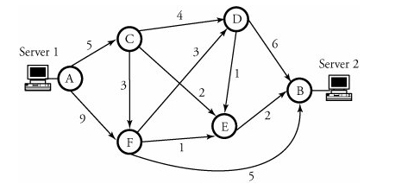 | CO3 | (06)
 | b) | Illustrate congestion control using Random Early Detection. | CO3 | (08)
 | c) | Consider a router that interconnects three subnets. Subnet1,subnet2 and subnet3. Suppose all the interfaces in each of these three subnets are required to have the prefix 223.1.17/24. Also suppose that subnet1 is required to support upto 125 interfaces and subnet 2 and 3 are required to support upto 60 interfaces. Provide three network addresses (of the form a.b.c.d/x) that satisfy these constraints. | CO3 | (06)
 |  | UNIT – IV
7. | a) | Discuss the Commonalities between mobile IP and GSM mobility. Suppose there are two ISPs providing WiFi access in an Internet café, with each ISP operating its own AP and having its own IP address block. i. Further suppose that by accident, each ISP has configured its AP to operate over channel 11. Will the 802.11 protocol completely break down in this situation? Discuss what happens when two stations, each associated with a different ISP, attempt to transmit at the same time. ii. Now suppose that one AP operates over channel 1 and the other over channel 11. How do your answers change? | CO4 | (08)
 | b) | Discuss five steps of Protocol-Independent Multicast (PIM) protocol for a domain with n LANs with suitable example. | CO4 | (06)
 | c) | Briefly explain the working of the Internet Group Membership Protocol (IGMP). | CO4 | (06)
8. | a) | What is meant by a handoff in GSM? With the help of suitable diagrams, describe the steps involved when a base station does decide to handoff a mobile user. What happens when the mobile moves to a base station that is associated with different MSC than the old base station. What happens when this inter MSC handoff occurs more than once. | CO4 | (07)
 | b) | Differentiate between active and passive scanning for access points in IEEE 802.11. | CO4 | (06)
 | c) | Briefly explain the working of MOSPF multicast protocols with an example. | CO4 | (07)
 |  | UNIT – V
9. | a) | Explain the components of SIP protocol. | CO5 | (05)
 | b) | What is the need of content distribution networks? Explain with an example CDN interactions with DNS. | CO5 | (08)
 | c) | Given figure shows four flows (A, B, C, and D) to be processed at one of the outputs of a router. For each packet, the time it arrives and its label are indicated in the figure. Specify the order of packets transmitted at this output, using the following schedulers. All schedulers scan the flows, starting from flow A.  - Priority queuing. Priorities decrease from line A to line D.  - Weighted fair queuing, where flows A, B, C, and D are given 20 percent, 10 percent, 40 percent, and 20 percent, respectively, of the output capacity.  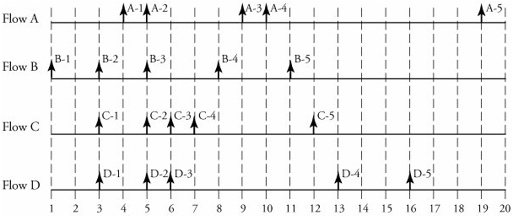 | CO5 | (07)
10. | a) | Explain in brief Stream Control Transmission Protocol (SCTP). | CO5 | (08)
 | b) | Discuss with an example leaky bucket traffic shaping algorithm. | CO5 | (06)
 | c) | Draw the frame format for real-time transport protocol and explain in brief. | CO5 | (06)

****************

